 | 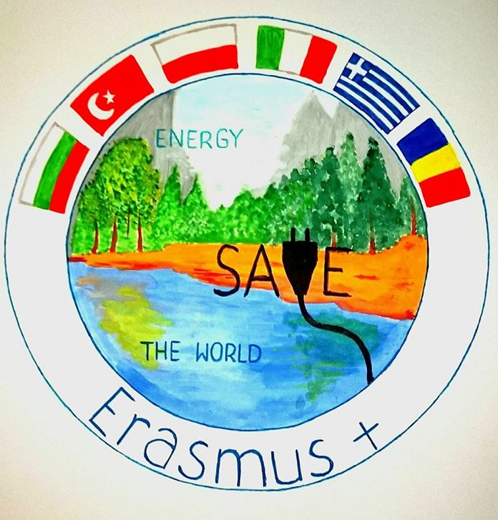
 |  | 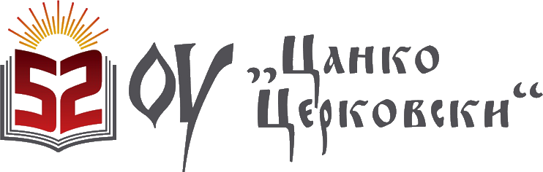

SAVE ENERGY, SAVE THE WORLD

ACTIVITY REVIEW
52 Primary School “Tsanko Tserkovski”, Sofia, Bulgaria
(NOVEMBER 2016 – FEBRUARY 2017)

87 students from 52 Primary School “Tsanko Tserkovski” have been questioned about the way they used electricity and water.
Children learn to use water and electricity saving them.
They know about the project SAVE ENERGY, SAVE THE WORLD and they are very enthusiastic.

WATER SAVING:
- Enough water use for personal care
- Water used unnecessarily
- Tap off
- Tap off – warning family members
Indicators  Students | November |  |  |  | December |  |  |  | January |  |  |  | February
Indicators  Students | 1 | 2 | 3 | 4 | 1 | 2 | 3 | 4 | 1 | 2 | 3 | 4 | 1 | 2 | 3 | 4
87  students |   76 | 7 | 76 | 65 | 80 | 12 | 80 | 72 | 82 | 7 | 80 | 76 | 80 | 10 | 78 | 70
87  students |   11 | 80 | 11 | 22 | 7 | 75 | 7 | 15 | 5 | 80 | 7 | 11 | 7 | 77 | 9 | 17

ENERGY SAVING
- Use electricity not unnecessarily
- Unnecessarily lights off
- Tap off
- Unnecessary electrical use; warning family memebers
Indicators  Students | November |  |  |  | December |  |  |  | January |  |  |  | February
Indicators  Students | 1 | 2 | 3 | 4 | 1 | 2 | 3 | 4 | 1 | 2 | 3 | 4 | 1 | 2 | 3 | 4
87  students | 80 | 15 | 76 | 70 | 85 | 10 | 80 | 70 | 81 | 7 | 77 | 76 | 75 | 10 | 78 | 76
87  students | 7 | 72 | 11 | 17 | 2 | 77 | 7 | 17 | 6 | 80 | 10 | 11 | 12 | 77 | 9 | 11

