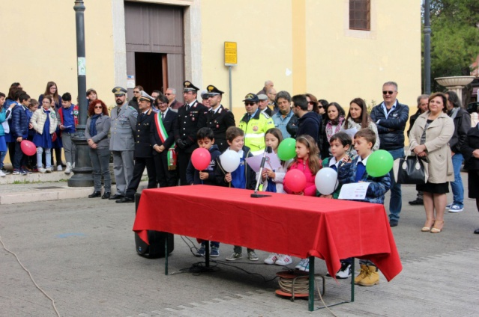

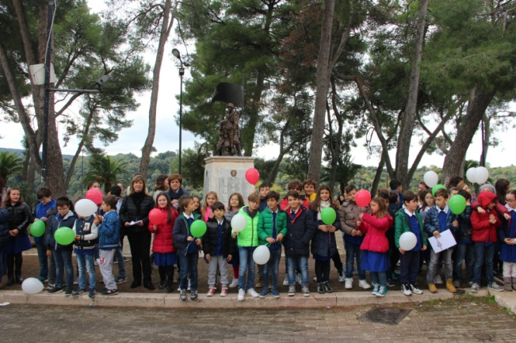

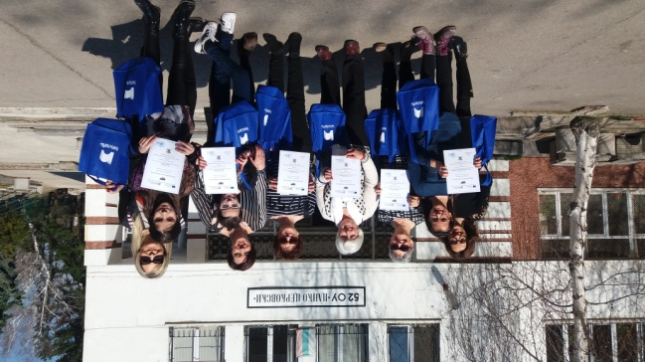

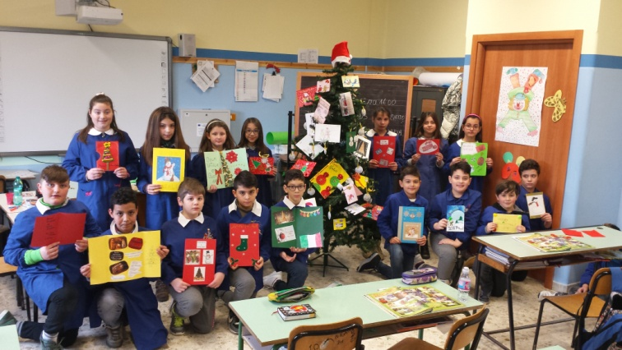 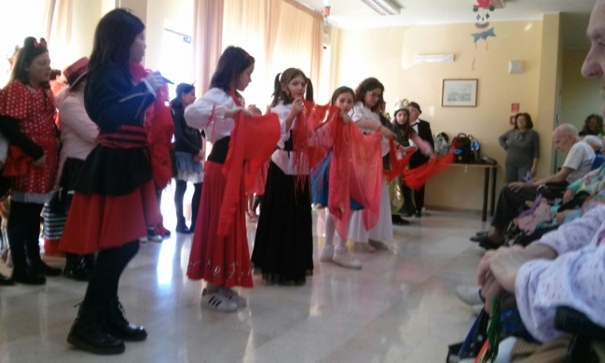 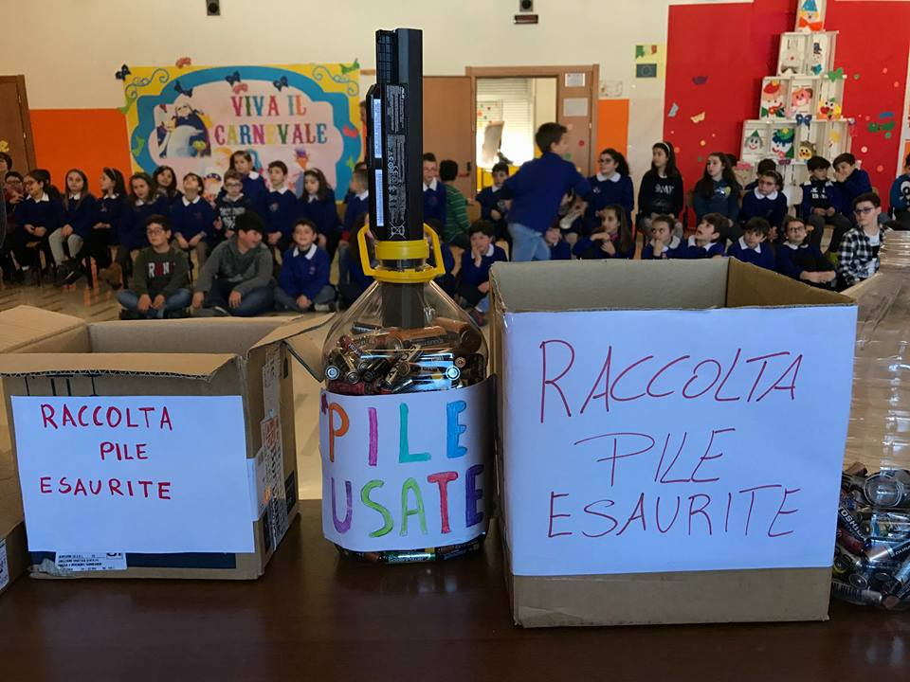

**Thanks To Visit us**

[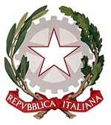](https://www.google.it/url?sa=i&rct=j&q=&esrc=s&source=imgres&cd=&cad=rja&uact=8&ved=0ahUKEwjL3pKsnvzSAhVDxRQKHc5tBpUQjRwIBw&url=http://www.quirinale.it/qrnw/simboli/emblema/emblema.html&psig=AFQjCNEWC-rpHDdmSbUnngXBysM6n87raQ&ust=1490894873511951)

Direzione Didattica Statale

“Piazza Quattro Novembre”

San Nicandro Garganico

[](https://www.google.it/url?sa=i&rct=j&q=&esrc=s&source=images&cd=&cad=rja&uact=8&ved=0ahUKEwju6ZOUybTTAhVDbRQKHRoaDXgQjRwIBw&url=http://erasmusplus-neo.org/&psig=AFQjCNFtXTpIRF7CzNQ68ahHTUweTy5XRw&ust=1492830492992362)

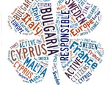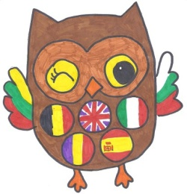 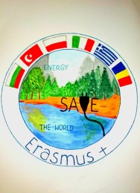

**Projects Activities Dissemination**

**_ “Learning beyond the classroom walls”**

**_“Responsible and Active Citizen of Europe”**

**_ “Save Energy Save the World”**



